Lab Updates
March 25, 2016

Announcements:

New Business:
Alex’s Adventures: Consensus meetings
STEP Home week 9, planning, step home paper
Interview with Morgan Marruso
CPT with TRT408

Ariye’s Affairs:

Arkadiy’s Account: This week I addressed IRB corrections for Marty Shenton's continuing review, grant preparation, trying to schedule a participant for Shenton study, and we did a Pilot scan for Shenton's study- all went well.

Cate's Collection: TRACTS consensus, Houston consensus, Morgan Postdoc Applicant visit, Lauren BATL v Polytrauma paper, Laura CVLT close blast paper, TRACTS cohort paper – getting closer, Neuropsychology review, STEP Home Feasibility paper

Chris’ Chronicles: I have been working on normalizing RESPONSE brain scans with Cory. I have been working on the BRAVE dataset and looking into papers to support our potential findings. I am also in the process of cleaning the RESPONSE dataset with Mallory. We are also continuing with RESPONSE recruitment.

Corbo's Convo:

DeGutis' Details:

Esterman's Events:

Fitzy’s Facts:

Francesca: Ran 1 billion rank sum tests with Mike and David. Otherwise, continuing with ongoing data analyses.

Grande's Going-Ons:

Hannah’s Happenings: Newsletter mailing, scoring/ scanning, teleforms, STEP Home wk. 9, STEP data entry, IRB work

Hide’s Hatchings: 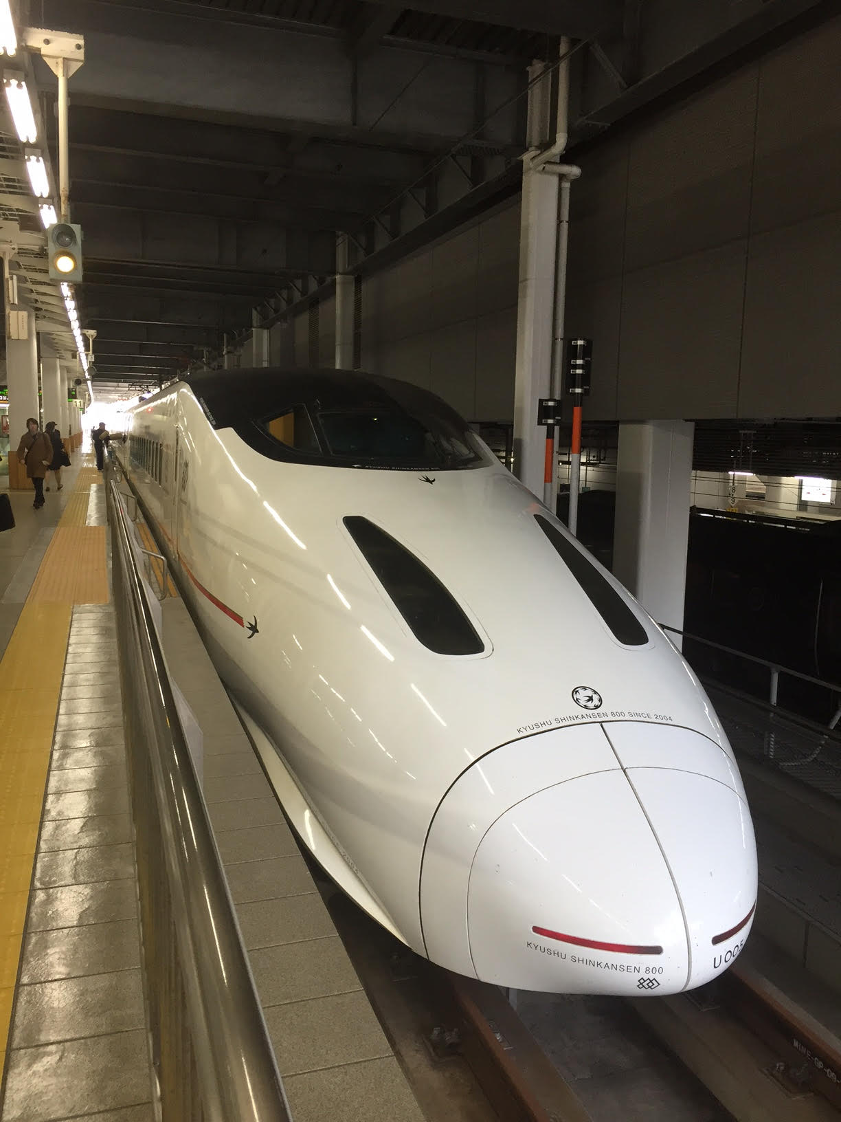 On vacation in Japan, rode a bullet train

Hursh’s Highlights: STEP Home week 9, various repository responsibilities, Core B admin, one new VR intake (CRV referral), follow-up work with other VR clients

Jackson’s Jive: TRACTS participant, Spark award webinars and project planning, NSI, Chapter, interview with Morgan, WHS-GEC resource guide

Jenn’s Jingle: NSI paper—additional analyses to address reviewer comments; TBI and suicide paper—all authors sent final comments, plan to submit over the weekend; Avanir—met to discuss further collaboration; set up meeting for potential statistics RA this Friday

Leritz’s Lowdown:

Lissa’s Learnings: Visited Alice Cronin-Golomb's lab to work on getting an eye tracking/pupil tracking task working, with good success
-Started writing an algorithm to automatically identify a particular gradCPT phenotype I found in the TRACTS data
-Worked with Mike and Joe on yet another revision of the gender paper
-Summarized all the analysis I've done so far on the TRACTS gradCPT data, in the process of deciding if it'll make a good paper

Mallory’s Moments:

Meghan’s Missive: PET processing, CDA Letter of intent, breath hold

Melissa’s Musings:

Michelle's Marvels: I submitted an amendment to update our MRI screen, I've been recruiting new participants for TMS, running analyses on the TRACTS datset

Nic’s News:

Nordstrom’s Notes:

Radigan’s Rants: ALERT audit prep, newsletter mailing, BVMT scoring, Shenton participant

Ryan’s Run-Down: TRACTS testing, scoring, IRB paperwork and literature review for exercise study, CPX data entry

Spielberg's Spiel:

Trotter’s Tales:

Vicky's Virtues:

Wally’s World:

VA IRB # | Project Title | Principle Investigator | IRB Point Person | Current Approval Dates | Project Status | Current Updates
1330 | Cognitive Changes Associated with Chronic Alcohol Abuse (Neuropsychological Assessment) | McGlinchey |  |  | Data analysis
1336 | Cognitive Changes Associated with Chronic Alcohol Abuse (Structural Magnetic Resonance Imaging Studies) | McGlinchey |  |  | Data analysis
1337 | Cognitive Changes Associated with Chronic Alcohol Abuse (Associative Learning Eyeblink Studies) | McGlinchey |  |  | Data analysis
1469 | Cognitive Processing in Hemispatial Neglect | Milberg |  |  | Data analysis
1470 | Cardiovascular Risk and Frontal Dysfunction in Black Elders | Milberg |  |  | Data analysis
1471 | Relating Cortical Function to Cerebrovascular and Dementia Risk | Milberg |  |  | Data analysis
1619 | Brief Cognitive Assessment in Individuals at Risk for Cerebrovascular Disease | Milberg |  |  | Data analysis
1706 | Brief Cognitive Assessment in Individuals with Diabetes | Milberg |  |  | Data analysis
1807 | Noise-Enhanced Galvanic Vestibular Stimulation in Hemispatial Neglect | Milberg |  |  | Closed
1818 | Memory Dissociations and Risk for Alzheimer’s Disease Versus Vascular Dementia | Milberg, Leritz |  |  | Open to enrollment
1825 | Classical Associative Learning in Male and Female Detoxified Veterans | McGlinchey |  |  | Data analysis
1943 | Cognitive Factors and Relapse in Chronic Alcoholism | Fortier | Arkadiy | 03/25/14-03/24/15 | Data analysis
2174 | Assessment of MR Image Quality | Leritz | Meghan R. | 9/10/13-9/9/14 | Open to enrollment
2314 | Non-spatial Attention Training and the Amelioration of Hemispatial Neglect | DeGutis | Joe/Chris |  | Data analysis
2351 | Classical Associative Learning in Male and Female Alcoholics (CIRCA) | McGlinchey | Katie | 9/24/13-9/23/14 | Open to enrollment
2354 | Translational Research Center for Traumatic Brain Injury and Stress Disorders: Human Characterization Core B | McGlinchey | Colleen | 9/10/13-9/9/14 | Open to enrollment
2358 | Translational Research Center for Traumatic Brain Injury and Stress Disorders: Associative Learning and Cognition in Individuals with TBI and PTSD (Project 1) | Fortier | Arkadiy | 09/24/13-09/23/14 | Open to enrollment
2389 | Translational Research Center for Traumatic Brain Injury and Stress Disorders: Structural and Functional Neuroimaging Studies (Core B; Project 3) | McGlinchey, Salat | Vince | 1/27/14 (ICF), 11/18/14 (CR) | Open to enrollment
2423 | Associative Learning and Brain Structure in Individuals at Risk for Dementia | Fortier | Arkadiy | 02/25/14-02/24/15 | Data analysis
2425 | Translational Research Center for TBI and Stress Disorders: Cognitive Processing Therapy in Individuals with TBI and PTSD (Project 2) | Rasmusson | Hannah | 3/11/14-3/10/15 | Data analysis
2444 | Structural and Functional Correlates of Attention and Distraction in the Brain | Esterman | Mike | 4/21/14 | Open to enrollment
2477 | Does retrogensis explain regional white matter integrity in MCI? | Stricker | Nikki | 8/13/13-8/12/14 | Data analysis
2479 | Translational Research Center for Traumatic Brain Injury and Stress Disorders: Vocational Rehabilitation Needs Assessment and Counseling | McGlinchey, Hursh | Colleen | 7/23/13-7/22/14 | Open to enrollment
2506 | Training Focus and Sustained Attention | DeGutis | DeGutis |  | Open to enrollment
2574 | Use of Publicly Available and Anonymized MRI Data | Salat | Ben | 6/11/13-? | Data analysis
2657 | Using transcranial magnetic stimulation to examine attention and distraction in the brain | Esterman | Mike | 8/12/14 | Open to enrollment
2662 | BRAVE Trial: Broad-spectrum Cognitive Remediation Available to Veterans: Effects of a Brain Plasticity-based Program in Mild Traumatic Brain Injury (mTBI) | Milberg | Chris/Joe | 2/10/14 | Open to enrollment
2672 | Tau Biomarkers Following Blast mTBI in OEF/OIF Veterans | McKee | Lauren | 10/14/14 | Open to enrollment
2681 | Translational Research Center for Traumatic Brain Injury and Stress Disorders: Data Repository | McGlinchey | Colleen | 10/15/13-10/14/14 | Data analysis
2685 | STEP-Home: Cognitive, Emotional and Vocational Reintegration for OEF/OIF Veterans (Pilot) | Fortier | Hannah | 11/9/13-11/18/14 | Open to enrollment
2811 | STEP-Home: Cognitive, Emotional and Vocational Reintegration for OEF/OIF Veterans (JIT) | Fortier | Hannah | 1/29/14 | Waiting on approval
2687 | Study of Pseudobulbar Palsy symptoms in Veterans with mild Traumatic Brain Injury | McGlinchey | Jenn | 10/29/13-10/28/14 | Data analysis
2779 | A novel approach to identifying behavioral and neural markers of active suicidal ideation: Effects of cognitive and emotional stress on working memory in OEF/OIF/OND Veterans | Amick | Molly | 02/10/14-11/03/14 | Open to enrollment
TBD | Rates of clinical impairment in the TRACTS cohort | Stricker | Stricker | TBD

