Lab Updates
October 2nd, 2015

Announcements:

New Business:
Alex’s Adventures: -Psych interview with TRT382.01
- Consensus and reliability meetings
-STEP Home planning, meetings, individual case meetings, and Group 2.
-CPT with TRT408
-Psych interview with TRT390.01

Ariye’s Affairs:

Arkadiy’s Account: 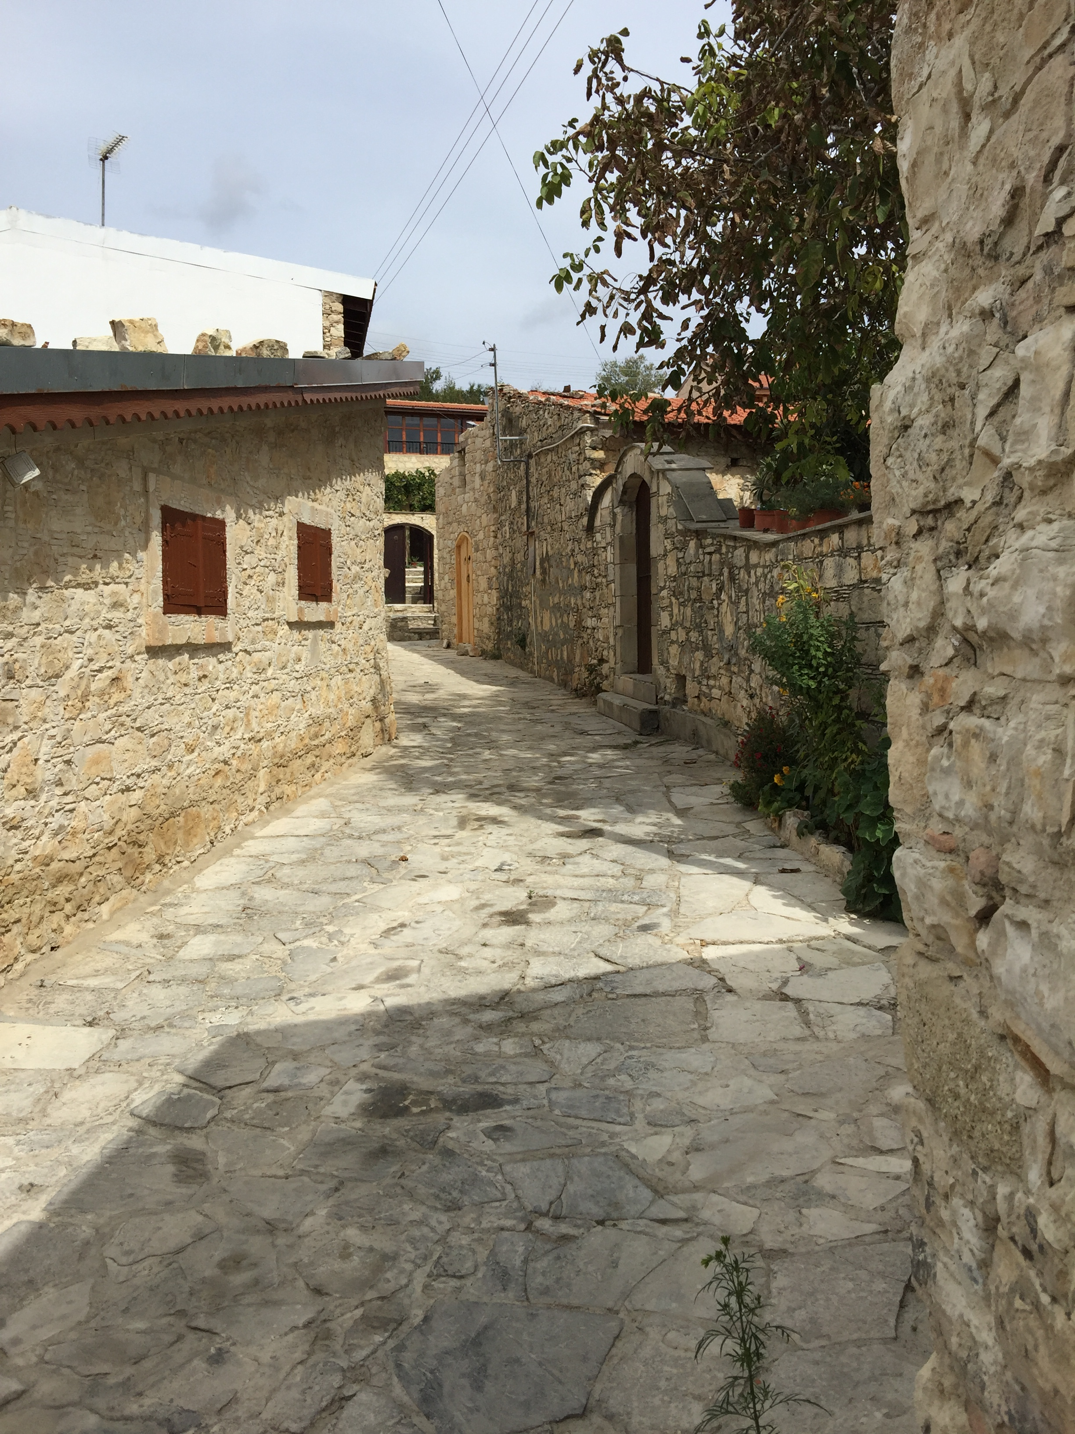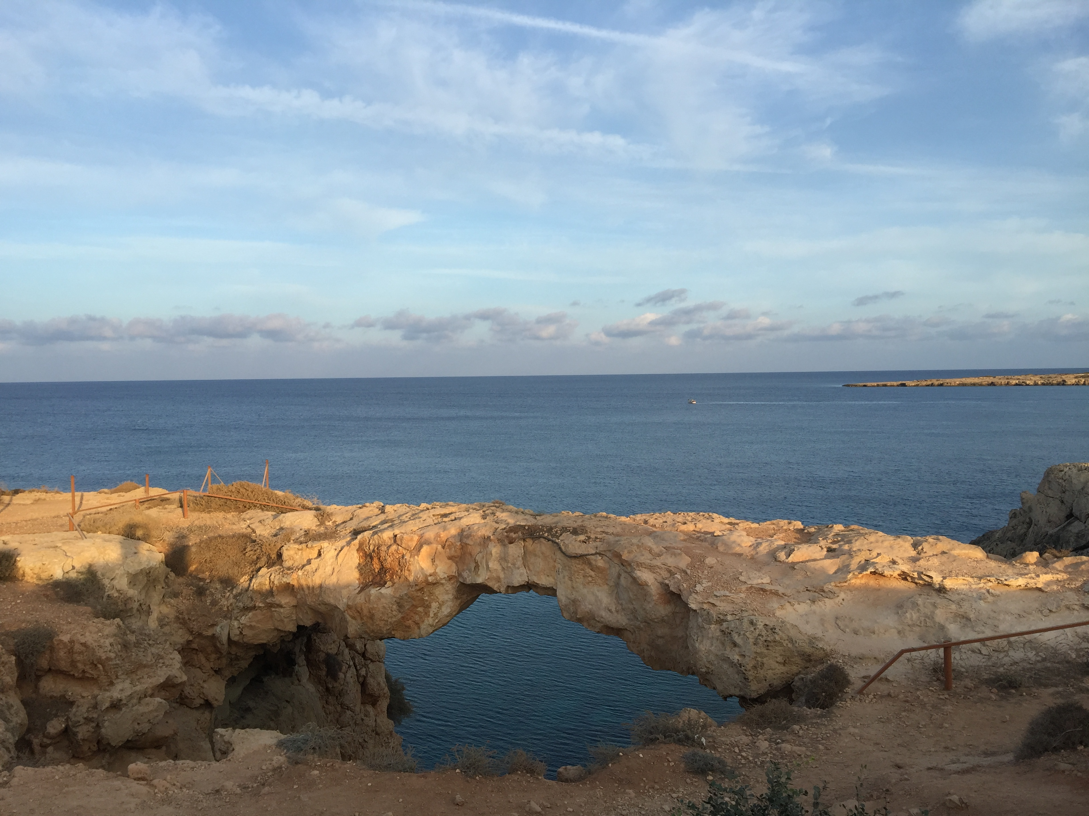

Cate's Collection: TRACTS consensus, Houston consensus, Houston trip planning, STEP, RA meeting, TMS trainings, TRACTS cohort paper

Chris’ Chronicles: I had a RESPONSE coaching session with a participant. I have 2 BRAVE sessions today. I have been doing a lot of recruitment for RESPONSE. I have also been doing additional analyses on the TRACTS data set. I have also been helping Michelle with her audit.

Corbo's Convo:

DeGutis' Details:

Esterman's Events:

Fitzy’s Facts: Working on new hires. Submitted 2 new positions descriptions for classification. Working on an application for a certificate of confidentiality. Starting to work on this year's TRACTS annual report.

Francesca:

Grande's Going-Ons:

Hannah’s Happenings: Tested first TRACTS participant, scoring, teleform review, STEP Home week 2, STEP data entry

Hide’s Hatchings: [BRAVE] follow-up with enrolled participants, preparing for tri-annual audit, V1 (10/02) and the mid-session (10/02); [RESPONSE] recruitment.

Hursh’s Highlights: STEP Home week 2, repository maintenance, VR phone calls, work with one VR client, Core B record keeping updates/internal audit

Jackson’s Jive:

Jenn’s Jingle:

Leritz’s Lowdown:

Mallory’s Moments:

Meghan’s Missive:

Melissa’s Musings: IRB meeting, consensus meetings, reviewed vincent’s manuscript, listened to one reliability CAPs case, preparing for triennial audit for SI study.

Michelle's Marvels: I worked on the triennial audit for 2657, ran analyses on the TRACTS dataset

Nordstrom’s Notes:

Radigan’s Rants: TRACTS testing / phlebotomy, training RAs, RA meeting, called people missing “names” category

Ryan’s Run-Down: worked on ICF's and protocol for Scott, observed Hannah test, and did a few analyses on my INS stuff.

Spielberg's Spiel:

Trotter’s Tales:

Vicky's Virtues:

Wally’s World:

VA IRB # | Project Title | Principle Investigator | IRB Point Person | Current Approval Dates | Project Status | Current Updates
1330 | Cognitive Changes Associated with Chronic Alcohol Abuse (Neuropsychological Assessment) | McGlinchey |  |  | Data analysis
1336 | Cognitive Changes Associated with Chronic Alcohol Abuse (Structural Magnetic Resonance Imaging Studies) | McGlinchey |  |  | Data analysis
1337 | Cognitive Changes Associated with Chronic Alcohol Abuse (Associative Learning Eyeblink Studies) | McGlinchey |  |  | Data analysis
1469 | Cognitive Processing in Hemispatial Neglect | Milberg |  |  | Data analysis
1470 | Cardiovascular Risk and Frontal Dysfunction in Black Elders | Milberg |  |  | Data analysis
1471 | Relating Cortical Function to Cerebrovascular and Dementia Risk | Milberg |  |  | Data analysis
1619 | Brief Cognitive Assessment in Individuals at Risk for Cerebrovascular Disease | Milberg |  |  | Data analysis
1706 | Brief Cognitive Assessment in Individuals with Diabetes | Milberg |  |  | Data analysis
1807 | Noise-Enhanced Galvanic Vestibular Stimulation in Hemispatial Neglect | Milberg |  |  | Closed
1818 | Memory Dissociations and Risk for Alzheimer’s Disease Versus Vascular Dementia | Milberg, Leritz |  |  | Open to enrollment
1825 | Classical Associative Learning in Male and Female Detoxified Veterans | McGlinchey |  |  | Data analysis
1943 | Cognitive Factors and Relapse in Chronic Alcoholism | Fortier | Arkadiy | 03/25/14-03/24/15 | Data analysis
2174 | Assessment of MR Image Quality | Leritz | Meghan R. | 9/10/13-9/9/14 | Open to enrollment
2314 | Non-spatial Attention Training and the Amelioration of Hemispatial Neglect | DeGutis | Joe/Chris |  | Data analysis
2351 | Classical Associative Learning in Male and Female Alcoholics (CIRCA) | McGlinchey | Katie | 9/24/13-9/23/14 | Open to enrollment
2354 | Translational Research Center for Traumatic Brain Injury and Stress Disorders: Human Characterization Core B | McGlinchey | Colleen | 9/10/13-9/9/14 | Open to enrollment | 3 repeat ICF's signed, received IRB approval to mail questionnaires
2358 | Translational Research Center for Traumatic Brain Injury and Stress Disorders: Associative Learning and Cognition in Individuals with TBI and PTSD (Project 1) | Fortier | Arkadiy | 09/24/13-09/23/14 | Open to enrollment
2389 | Translational Research Center for Traumatic Brain Injury and Stress Disorders: Structural and Functional Neuroimaging Studies (Core B; Project 3) | McGlinchey, Salat | Vince | 1/27/14 (ICF), 11/18/14 (CR) | Open to enrollment
2423 | Associative Learning and Brain Structure in Individuals at Risk for Dementia | Fortier | Arkadiy | 02/25/14-02/24/15 | Data analysis
2425 | Translational Research Center for TBI and Stress Disorders: Cognitive Processing Therapy in Individuals with TBI and PTSD (Project 2) | Rasmusson | Hannah | 3/11/14-3/10/15 | Data analysis
2444 | Structural and Functional Correlates of Attention and Distraction in the Brain | Esterman | Mike | 4/21/14 | Open to enrollment
2477 | Does retrogensis explain regional white matter integrity in MCI? | Stricker | Nikki | 8/13/13-8/12/14 | Data analysis
2479 | Translational Research Center for Traumatic Brain Injury and Stress Disorders: Vocational Rehabilitation Needs Assessment and Counseling | McGlinchey, Hursh | Colleen | 7/23/13-7/22/14 | Open to enrollment | no new updates
2506 | Training Focus and Sustained Attention | DeGutis | DeGutis |  | Open to enrollment
2574 | Use of Publicly Available and Anonymized MRI Data | Salat | Ben | 6/11/13-? | Data analysis
2657 | Using transcranial magnetic stimulation to examine attention and distraction in the brain | Esterman | Mike | 8/12/14 | Open to enrollment
2662 | BRAVE Trial: Broad-spectrum Cognitive Remediation Available to Veterans: Effects of a Brain Plasticity-based Program in Mild Traumatic Brain Injury (mTBI) | Milberg | Chris/Joe | 2/10/14 | Open to enrollment
2672 | Tau Biomarkers Following Blast mTBI in OEF/OIF Veterans | McKee | Lauren | 10/14/14 | Open to enrollment | CR had changes required, amendment deferred
2681 | Translational Research Center for Traumatic Brain Injury and Stress Disorders: Data Repository | McGlinchey | Colleen | 10/15/13-10/14/14 | Data analysis | received continuing review approval
2685 | STEP-Home: Cognitive, Emotional and Vocational Reintegration for OEF/OIF Veterans (Pilot) | Fortier | Hannah | 11/9/13-11/18/14 | Open to enrollment
2811 | STEP-Home: Cognitive, Emotional and Vocational Reintegration for OEF/OIF Veterans (JIT) | Fortier | Hannah | 1/29/14 | Waiting on approval
2687 | Study of Pseudobulbar Palsy symptoms in Veterans with mild Traumatic Brain Injury | McGlinchey | Jenn | 10/29/13-10/28/14 | Data analysis
2779 | A novel approach to identifying behavioral and neural markers of active suicidal ideation: Effects of cognitive and emotional stress on working memory in OEF/OIF/OND Veterans | Amick | Molly | 02/10/14-11/03/14 | Open to enrollment
TBD | Rates of clinical impairment in the TRACTS cohort | Stricker | Stricker | TBD

